**Logical design of UI layout**

Main Menu of App(ScreenMainMenu)

Set three buttons to go through the student, Report system and Admin screen

Add the picture

Set the background

Screen of student (ScreenStudent)

This screen is the list of student information including student name, SUID and college name. it is linked by the button “Student” in the mainMenu

We could use search menu to find the information that we need.

Set Lift the sorting

Gallery Data source

Student

Change Fields: Name, SUID and college name.

Add Searching and Add Sorting

Back Icon Navigation

ScreenMainReported linked by the button “Reported system” in the ScreenMainMenu

This screen is used to upload all kind of information such as travel report, test result etc for student.

Set Background image

Add title and Back Icon

Add six Buttons

Fix Navigation Between Both Screens

View Travel Report (ScreenViewTravelReport)

New Form Screen

Delete he Edit Form and add the Detail Form

Back Icon, delete Icon and edit Icon

Set Fields: student name, Travel Location, date and days

Edit Travel Report (ScreenEditTravelReport)

New Edit Screen

Back Icon and Add Icon

Add Fields: Travel Location, student name, date and days.

Make activity report (ScreenPartyReport)

Same thing with the ScreenEditTravelReport

Fever Report (ScreenFeverReport) same thing

Test Report

Set list of the COVID test Report

Set Fields: student name, date and the test result

Same thing with the test Report but it is for the Course status

Students could see their course are online or in-person

Main Menu of the manager system (ScreenMainAdmin)

Set background image

Set two buttons

Back Icon

Title

Course status management (ScreenControlCourseStatus)

Set EitForm for the manager to change the course status according to the COVID situation

Back Icon and edit Icon

Add Fields: Course code, Course mode and the student name

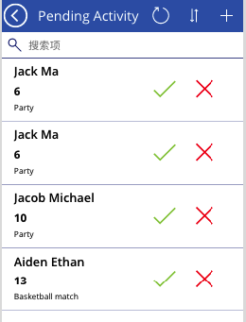

Pending Activity (ScreenPendingActivity)

Set Activity Report list to the manager, the manager could decide to give permit or not from the student activity request

Set Fields: student name, The number of activities and the activity type.

Back Icon

Search

Sort

Allow and not allow Icon